**DAILY ONLINE ACTIVITIES SUMMARY**

|  |  |  |  |  |  |  |  |  |
| --- | --- | --- | --- | --- | --- | --- | --- | --- |
| **Date:** | 14-06-2020 | | | | | **Name:** | Anvitha H M | |
| **Sem & Sec** | 4th ‘A’ | | | | | **USN:** | 4AL18CS010 | |
| **Online Test Summary** | | | | | | | | |
| **Subject** | | - | | | | | | |
| **Max. Marks** | | - | | **Score** | | | - | |
| **Certification Course Summary** | | | | | | | | |
| **Course** | Front end development - CSS. | | | | | | | |
| **Certificate Provider** | | | Great learning academy | | **Duration** | | | 8 hours |
| **Coding Challenges** | | | | | | | | |
| **Problem Statement:** C program to remove the specific character from the string. | | | | | | | | |
| **Status:** Executed | | | | | | | | |
| **Uploaded the report in Github** | | | | | YES | | | |
| **If yes Repository name** | | | | | <https://github.com/alvas-education-foundation/Anvitha-H-M> | | | |
| **Uploaded the report in slack** | | | | | Yes | | | |

**Online test:**

N/A

**Certification course:**

Front end development - CSS

The course includes detailed explanation on color and hexadecimal, opacity, introduction to box model, width, height, min and max width, padding, margin, border, insertion of background, styling the background image, front styling and the course ended with quiz on theory which we came across in this course, assignment to prepare a web page using HTML and CSS.

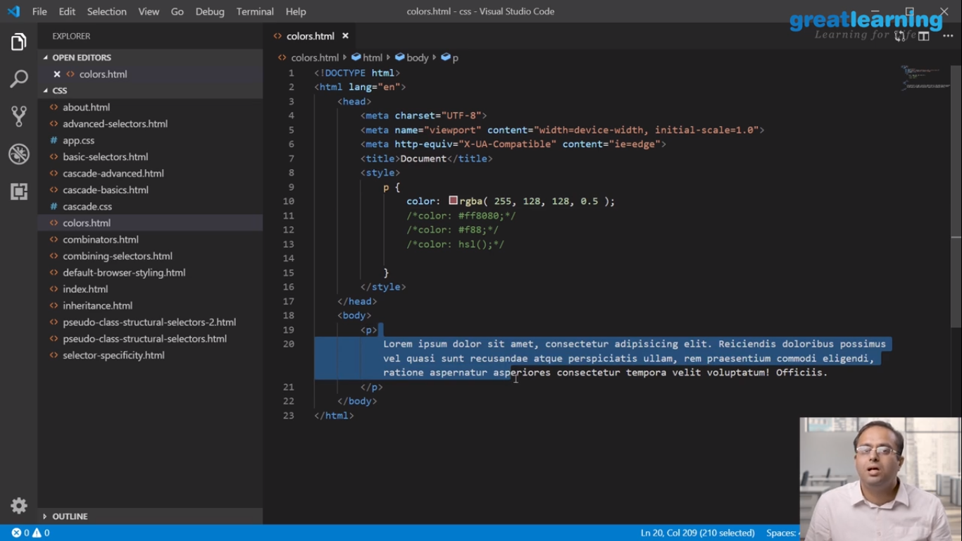

Online coding challenge

The programing statement of the day is

“Program in C to remove the specific character from the string”.

Solution: Executed and uploaded in Github repository.

Link: <https://github.com/alvas-education-foundation/Anvitha-H-M>

